

**Fatima Jinnah Women University**

**Submitted to: Sir Adeel Khalid**

**Submitted by: AimenJillani (001)**

**Kainat Bibi (017)**

**Maryam Siddiqui (027)**

**Natasha Kanwal (032)**

**Noor Fatima (035)**

**Wishma Noor (041)**

**Course: Artificial Intelligence**

**Semester/Department: BCS (6thSemester)**

**Table of Contents**

Introduction 2

Objectives 2

Computer 2

Applications 3

Methodology 3

Dataset 4

Technical 4

Implementation 4

Algorithm 4

CNN 4

CNN Basics 4

Key 5

Functionality 5

Learning 5

Automated 5

Importance 5

Conclusion 5

**REFERENCES** 6

**Gender and Age Detection**

# **Introduction**

The **"Gender and Age Detection"** project employs Deep Learning to classify gender and age from facial images using pre-trained models by **Tal Hassner** and **Gil Levi**. It categorizes gender as 'Male' or 'Female' and **age into predefined ranges**, acknowledging the **inherent variability in facial features**. This project showcases the **fusion of computer vision and Deep learning, offering practical insights into real-world applications**

Facial recognition technology has rapidly evolved, offering new possibilities for understanding human demographics and behavior. In this proposal, we aim to explore the application of gender and age detection from facial images in various domains, leveraging cutting-edge deep learning techniques.

[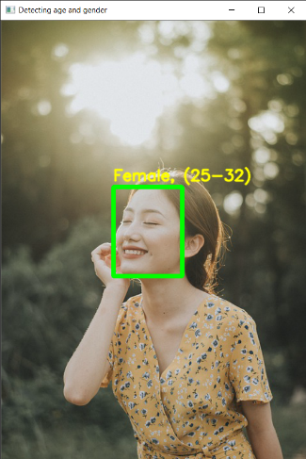](https://github.com/smahesh29/Gender-and-Age-Detection/blob/master/Example/Detecting%20age%20and%20gender%20girl1.png)

**Objectives**

Our objective is to develop a robust system for accurately **identifying gender and age** from **facial images** and explore its potential applications across different industries.

**Computer Vision**

Computer Vision enables computers to **interpret digital images and videos** similarly to humans. It involves **acquiring, processing, and analyzing visual data to extract meaningful information for decision-making**. Challenges arise from the complexity of replicating human vision. Key tasks include **object recognition, video tracking, motion estimation, and image restoration.**

# **Applications:**

* **Security and Surveillance**: Enhance access control and monitor individuals in public spaces.
* **Marketing and Advertising**: Tailor advertisements based on demographic information obtained from facial analysis.
* **Healthcare:** Analyze patient demographics for personalized healthcare services and medical research.
* **Entertainment:** Provide personalized content recommendations and interactive experiences.
* **Retail:** Analyze customer demographics for targeted product recommendations and store layout optimization.
* **Education:** Customize educational content and resources based on student demographics and preferences.
* **Human Resources**: Streamline recruitment processes by analyzing candidate demographics and assessing workforce diversity.
* **Social Media:** Enhance user experience by providing personalized content and targeted advertisements.

**Methodology:**

* **Data Collection and Preprocessing**: We will gather a **diverse dataset of facial images**, ensuring representation across different demographics and environments. Data preprocessing techniques will be employed to standardize image size, orientation, and quality, enhancing model performance.
* **Model Development**: Utilizing **convolutional neural networks (CNNs)**, we will develop models capable of **automatically learning relevant features for gender and age detection from facial images**. Training will be conducted using techniques like data augmentation to improve model robustness.
* **Evaluation:** Model performance will be evaluated using **standard metrics such as accuracy, precision, recall, and F1-score.** We will validate the models on test datasets to assess their generalization capabilities.

The work flow of the proposed age and gender predictor is

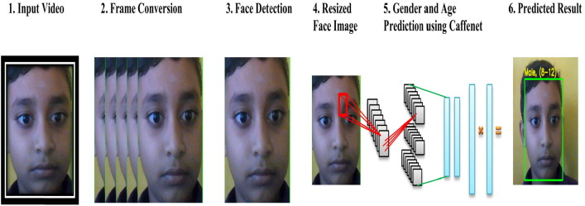

# **Dataset**

The Python project utilized the Adience dataset, **comprising over 26,000 facial photos of approximately 2,000 individuals**. This dataset encompasses diverse real-world conditions like lighting and poses. Trained on Adience, the project's models accurately predict gender and age from facial images.

**Technical FrameWork**

* **OpenCv** The purpose of OpenCV is for **image processing and computer vision tasks within the Python project.**
* **argparse** The purpose of argparse is to **handle command-line arguments passed to the Python script, making it easier to parse and process user inputs.**
* **TensorFlow** is a popular **open-source machine learning framework developed by Google**. It's known for its flexibility, scalability, and comprehensive ecosystem, making it suitable for building and deploying machine learning models across various platforms.

**Implementation Steps**:

* **Face Detection**: Use pre-trained TensorFlow model to identify faces.
* **Age and Gender Prediction**: Employ separate models for gender and age estimation, trained on Adience dataset.
* **Integration**: Combine components into user-friendly application for image or video input.

# **Algorithm**

* **Algorithm:** Utilize Convolutional Neural Network (CNN).
* **Training:** Train CNN on Adience dataset.
* **Purpose:** Recognize patterns for age and gender classification.

**CNN Architecture**

**CNN** **Basics**:

CNNs are specialized neural networks used in Computer Vision tasks within AI, designed to interpret visual information like images.

**Key Components:**

* **Input Layer**: Receives raw data, often pixels from images.
* **Hidden Layers**: Consist of Convolutional, Pooling, and Fully Connected layers.
* **Output Layer**: Produces final predictions, often using softmax for classification tasks.

**Functionality:**

* **Convolutional Layers:** Detect important features like edges in images.
* **Pooling Layers**: Simplify information by reducing dimensionality.
* **Fully Connected Layers:** Make final decisions based on extracted features.

**Learning Process:**

CNNs use feedforward to pass data through layers and adjust weights through backpropagation to minimize errors.

**Automated Feature Extraction:**

CNNs automatically find important patterns in data, eliminating the need for manual feature selection.

# **Importance:**

CNNs are crucial for accurate image and video analysis in modern AI applications due to their ability to handle complex visual tasks effectively.

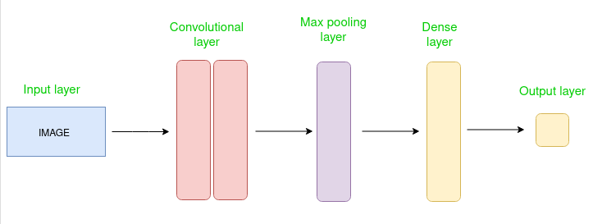

# 

# **Conclusion**

This project showcases the power of deep learning in computer vision, accurately classifying gender and age from facial features. Despite challenges, it achieves high accuracy due to robust CNN models and the Adience dataset. Future improvements could focus on dataset expansion, model refinement, and real-time optimization, offering a practical tool for biometric analysis and inspiring further AI research.

## **REFERENCES:**

* <https://www.sciencedirect.com/science/article/pii/S2214785320362222#b0030>
* <https://www.kdnuggets.com/2019/04/predict-age-gender-using-convolutional-neural-network-opencv.html>
* <https://www.geeksforgeeks.org/age-and-gender-prediction-using-cnn/>
* <https://medium.com/@skillcate/gender-detection-model-using-cnn-a-complete-guide-279706e94fdb>